Preliminary Report on Marine Fishing Gears Survey in Kingdom of Cambodia

21-29 August 2003

Pratakphol PRAJAKJITT, Narong RUANGSIVAKUL and Songphon CHINDAKAN

Southeast Asian Fisheries Development Center/Training Department

P.O.BOX 97, Prasamut Chedee, Samutprakarn. Thailand

1.0 Introduction

Refer to the 33rd Council Meeting of SEAFDEC in Singapore; The Council assured Cambodia that SEAFDEC would extend its assistance to Cambodia in all aspects of fisheries. In this connection, SEAFDEC/TD has published a series of book on ‘Fishing Gear and Method in Southeast Asia’. Up to present, this series covered 4 countries such as Thailand, Malaysia, The Philippines and Vietnam. For this year, SEAFDEC/TD proposed to conduct fishing gear survey on ‘Fishing Gear and Method in Coastal Area of Cambodia’ under Special 5 Years Program on Responsible Fishing Technologies and Practices.
Survey Team composed of 3 Fishing Gear Researchers from SEAFDEC/TD namely Mr. Pratakphol Prajakjitt, Mr. Narong Ruangsivakul and Mr. Songphon Chindakhan, accompanied with 3 Fisheries Officers from Cambodia Department of Fisheries (2 officers from Central Authority and 1 from each Local Fisheries Provincial Office). Survey period was during 21-29 August 2003. Fishing Gear Survey was conducted in 4 provinces along the coastline such as Koh Kong, Sihanouk Ville, Kampot and Kep. Ninty-one (91) samples of fishing gear were observed and recorded.
Fishing gear-surveying procedure is to measure and record all details of the gears such as size of the gears, textile materials, material of gear accessories, fishing gear arrangement and operational method. Interviews with fishers were done during survey for each gear in order to clarify fishing season, amount and type of catch and by-catch in each fishing trip and number of crew on board.

2.0 Result

As mentioned earlier, fishing gear survey was done in four provinces along the Cambodia coastline. Fishing ports, districts and villages name are described together with surveyed gears of each province such as followed.

2.1 Koh Kong Province
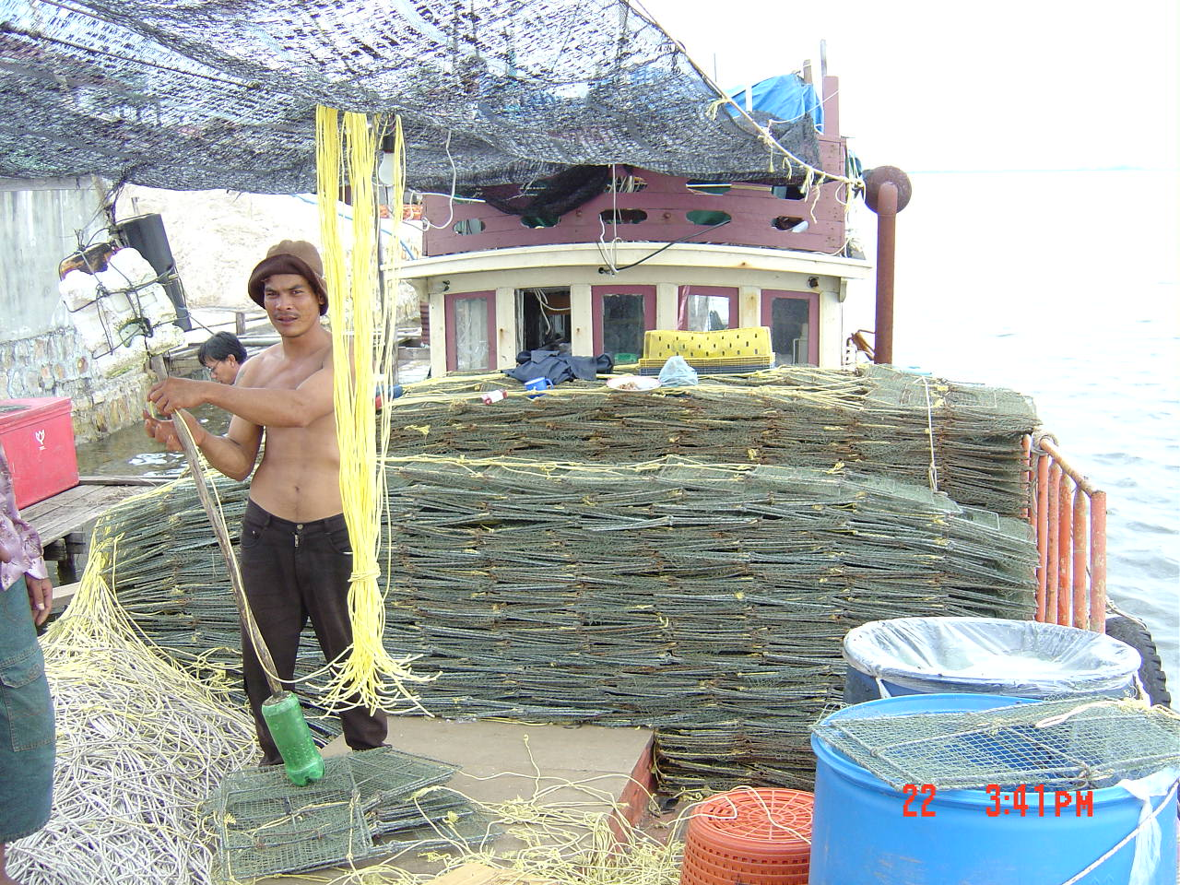
Six areas in Koh Kong Province were visited during 22-24 August. In Aug Doung Tuk, Koh Kong city, Dantung, Bak Klong and Peam Krasob, the most frequency gear observed was gill net, especially swimming crab gill net. In such mentioned area, mostly, small-scale fishing gears are observed but there are some large-scale fishing gears as well such as Trawler and Spanish mackerel longline in Bak Klong, Push net and Fyke net in Peam Krasob and large scale swimming crab trap in Koh Kong city. (Pic.1)
In Koh Sdach, which is island, situated fishing village that most fisher operate many kinds of gill net such as Swimming crab gill net, Queenfish gill net and etc. Large-scale swimming crab gill net with on-board crab boiler was observed
Detail of observed areas and fishing gears are in table 1.

Pic.1. Large Crap trap boat in Koh Kong

Map 1. Map of The Cambodian Coast and The Surveyed Places

Table.1. Place of fishing gear survey in Koh Kong

Province | District/Village | Group of  Fishing Gear | Name of Gear | Date of  Recorded
Koh Kong | 1. Aug Doung Tuk | Gill Net | Shrimp Trammel Net | 22/8/03
 |  |  | Sillago gill net
 | 2. Koh Kong | Trap | Collapsible crab trap
 |  |  | Cuttlefish trap
 | 3. Dang Tung | Gill Net | Mackerel gill net
 |  |  | Swimming crab gill net
 |  | Trap | Mud crab trap
 |  | Hook & Line | Ray & shark longline
 | 4.Bak Klong | Gill Net | Sillago gill net | 23/8/03
 |  |  | Fourfinger threadfin gill net
 |  |  | Mackerel gill net
 |  |  | White sea bass encircling gill net
 |  | Trawl | Shrimp trawl
 |  |  | Fish trawl
 |  | Trap | Grouper trap
 |  |  | Fyke net for krill
 |  |  | Octopus trap
 |  | Hook & Line | Spanish mackerel longline
 |  |  | Spanish mackerel troll line
 | 5. Peam Krasob | Gill Net | White sea bass gill net
 |  |  | Fourfinger threadfin encircling gill net
 |  | Push Net | Push net
 |  |  | Krill push net
 |  | Trap | Fyke net
 |  |  | Krill fyke net
 |  | Hook & Line | Ray & shark longline
 |  | Miscellaneous | Scoop net
 |  |  | Shrimp and fish fork
 | 6. Koh Sdach | Gill Net | Shrimp Trammel Net | 24/8/03
 |  |  | Spanish mackerel gill net
 |  |  | Scad gill net
 |  |  | Queenfish gill net
 |  |  | Swimming crab gill net I
 |  |  | Swimming crab gill net II
 |  |  | Swimming crab gill net (Large scale)
 |  | Hook & Line | Squid troll line
 |  |  | Catfish longline
 |  | Trap | Collapsible crab trap
 |  |  | Round-shape crab trap
 |  |  | Fish trap
 |  |  | Cuttlefish trap
 |  | Miscellaneous | Scoop net for squid
 |  |  | Scoop net for jellyfish

2.2 Sihanouk Ville
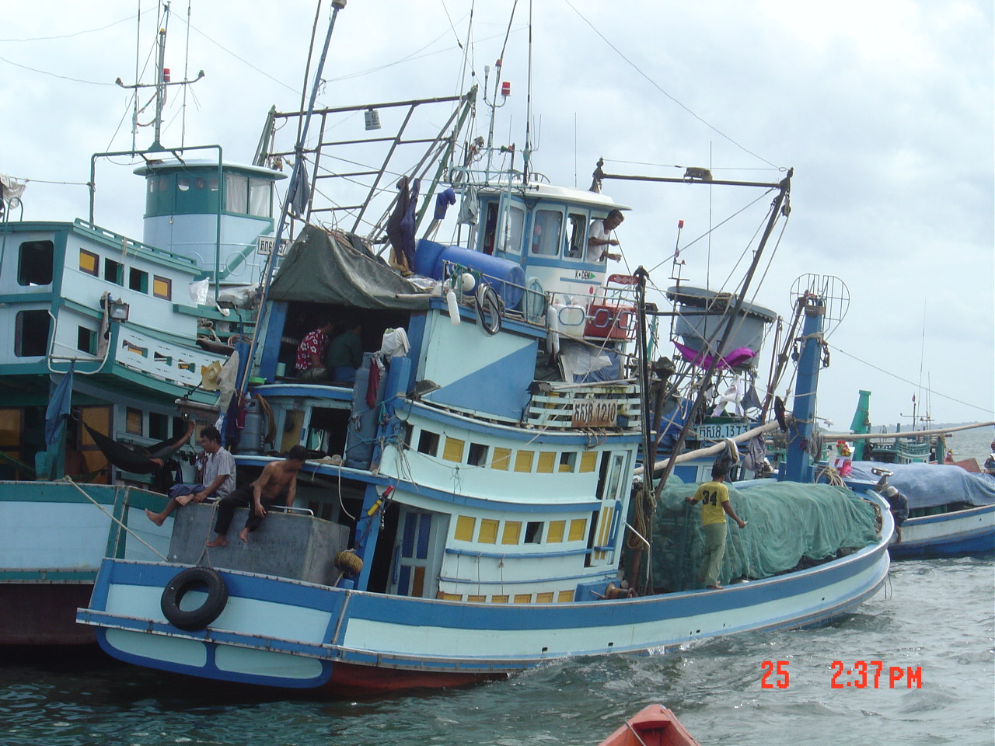
Two areas in Sihanouk Ville were visited during 25-26 August. In Tomnop Rolok, Many large-scale fishing gears and fishing vessels were observed such as Mackerel purse seine, Anchovy purse seine, large-size trawler and Spanish mackerel gill net boat. Medium-size trawler and gill net boat powered with long-tail engine also widely seen over there.
In Koh Kchyong, push net on long-tail engine boat is the most frequency gear, followed by gill net and some other miscellaneous gears. During survey, two blood cockle clam dredge fishing boats were observed. Recorded fishing gears are namely in Table 2.
Pic.2. Mackerel purse seine boats in Tomnop Rolok, Sihanouk Ville

Table.2. Place of fishing gear survey in Sihanouk Ville

Province | District/Village | Group of  Fishing Gear | Name of Gear | Date of  Recorded
Sihanouk Ville | 1. Tomnop Rolok | Gill Net | Mackerel encircling gill net | 25/8/03
 |  |  | Mackerel gill net
 |  |  | Spanish mackerel gill net
 |  | Purse Seine | Mackerel purse seine I
 |  |  | Mackerel purse seine II
 |  |  | Anchovy purse seine
 |  | Trawl | Bottom trawl
 |  | Dredge | Surf clam dredge
 | 2. Koh Kchyong | Gill Net | Threadfin bream gill net | 26/8/03
 |  |  | Sillago gill net
 |  |  | Shrimp gill net
 |  |  | White sea bass gill net
 |  | Fyke Net | Fyke net
 |  | Dredge | Blood cockle dredge
 |  | Push Net | Man-push net
 |  |  | Push net
 |  |  | Krill push net
 |  | Miscellaneous | Mud crab hook
 |  |  | Shrimp fork

2.3 Kampot Province
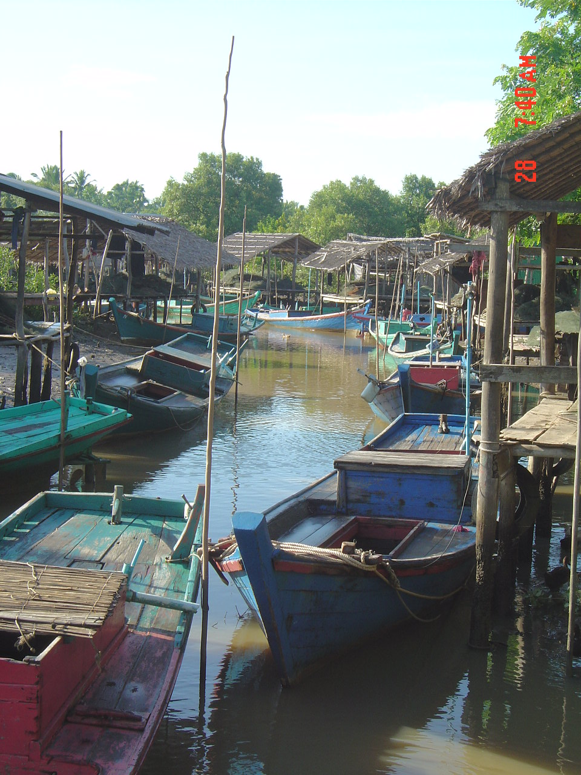
There were 6 areas in Kampot Province that survey team have been visited during 27-28 August. In Kdad, Prek Ampil, Prek Chek and Kampong Bay, mostly small-scale fishing gears were seen. Various types of gill net conducted with small boat (long-tail engine) are widely used in this area. In Prek Ampil, also found small-sized bamboo stake trap situated nearby seaweed culture area. Encircling seine was observed in Phom Sre’ and Kbal Romeas. Fishing boats for Encircling seine fishing operation are about 10-13 meters with inboard engine and 5 crews onboard. During off-season for encircling seine, small-size otter board trawl net being used instead. Recorded fishing gears found in Kampot Province are namely in Table 3.

Pic.3. Encircling seine fishing boats alongside in canal in Kbal Romeas Village, Kampot Province.

Table.3. Place of fishing gear survey in Kampot Province

Province | District/Village | Group of  Fishing Gear | Name of Gear | Date of  Recorded
Kampot | 1. Kdad | Gill Net | Mullet encircling gill net | 27/8/03
 |  | Trawl | Bottom Trawl
 |  | Cast Net | Sardine cast net
 | 2. Prek Ampil | Gill Net | Halfbeak encircling gill net
 |  |  | Spinefoot gill net
 |  | Trap | Fish trap
 |  |  | Shrimp trap
 |  |  | Bamboo stake trap
 |  | Miscellaneous | Spear
 | 3. Prek Chek | Gill Net | Halfbeak gill net
 |  |  | Terapon gill net
 |  | Trap | Swimming crab trap
 |  |  | Bamboo stake trap I
 |  |  | Bamboo stake trap II
 |  | Hook & Line | Cuttlefish troll line
 |  | Miscellaneous | Collecting shell by diving
 | 4. Kampong Bay | Gill Net | Shark gill net
 |  |  | Croaker gill net
 |  | Hook & Line | Spanish mackerel longline
 | 5. Phom Sre’ | Gill Net | Shad gill net
 |  | Seine Net | Encircling seine
 | 6. Kbal Romeas | Trawl | Bottom trawl | 28/8/03

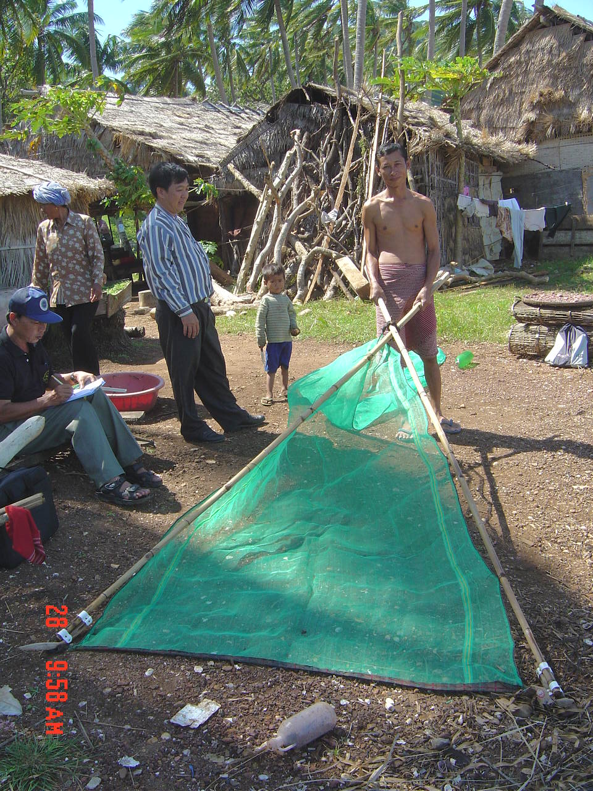
2.4 Kep Province
There were 4 areas in Kep Province that survey team visited on 28 August. The most frequently seen fishing gear is Swimming crab gill net. Krill push net by man along the beach also widely used (fishing season is May-October). One of deep-water bamboo stake trap, which catching fish in the chamber by ring net, was observed in Ou Krasa Village. Recorded fishing gears found in Kap Province are namely in Table 4.

Pic.4. Krill push net operated by man in Kep Province

Table.4. Place of fishing gear survey in Kep Province

Province | District/Village | Group of  Fishing Gear | Name of Gear | Date of  Recorded
Kep | 1. Kep | Push Net | Krill push net | 28/8/03
 | 2. Phum Thmey | Gill Net | Mullet gill net
 |  | Encircling Seine | Fine-meshed encircling seine
 | 3. Ou Krasa | Trap | Deep-water bamboo stake trap
 |  | Hook & Line | Ray & shark longline
 |  | Miscellaneous | Lifting scoop net
 | 4. Kep Village | Seine | Beach seine

3.0 Conclusion and Discussion

After 8 days in fishing gear surveying along the Cambodian coastline, the biggest fishing port, which has many commercial fishing boats such as trawler, purse seiner and gill net fishing boat alongside, is at Sihanouk Ville (Tomnop Rolok). Whilst other fishing ports or fishing villages mostly have small gill net fishing boats together with swimming crab trap fishing boats. Fishing boat size that was frequently seen is 10-13 meters in LOA (Length Over All) and powered with 10-15 HP onboard or long-tail engines. During survey period, which during rainy season, found that fishing activity such as crab gill net, White Sea bass gill net, trammel net for shrimp and krill fishing (by fyke net and push net) is in the peak season. On the contrary, fishing gear such as Mackerel purse seine, Queenfish gill net and Grouper trap are rarely operate due to weather condition and strong current.

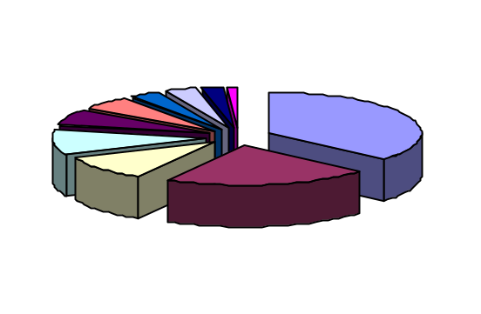
GILL NET
CAST NET
SEINE
PURSE SEINE
DREDGE
TRAWL
PUSH NET
MISC.
HOOK
TRAP
Pic.5 Composition of fishing gear sample (by Category)

From 91 samples of recorded, gill net is the most discovered gear among others (31 samples) followed by trap –20 samples, hook & line and miscellaneous gear (such as scoop net, spear and etc.) 9 samples. Large-scale fishing gears such as purse seines that could only found in Sihanouk Ville were collected 3 samples (2 Mackerel purse seine and 1 Anchovy purse seine). Swimming crab-fishing boats, trap and onboard-crab boiler, in large-scale that could catch hundreds-tons of swimming crab per trip were recorded.
There was only time limited in each survey area caused difficulty in collecting all details of some complicated gear. Spare time should be prepared in the next survey for any delay during the trip. Local Fishery Officer is also a key person to bring Researcher to the proper place that target fishing gears located. In addition, because of knowing people in local village, the interview with fisher will be friendlier then precise information could be collected.

4.0 Acknowledgement

All Researchers from SEAFDC/TD would like to express thanks to Mr.Niwes Ruangpanit and Dr.Somboon Siriraksophon to trust and give a great chance to accomplish this survey. Thanks also to Director and Deputy Director of Cambodia Department of Fisheries, Mr. Nao Thuok and Mr. Ing Try, to arrange all programs and very best take care during our visit. For all Cambodian colleagues, the survey team would like to give the special thanks for a great helpful during the survey trip.

